

Course program

AOTrauma Masters Course—

Lower Extremity

Course: December 9–14, 2012 Davos, Switzerland

Lecture hall: Flüela

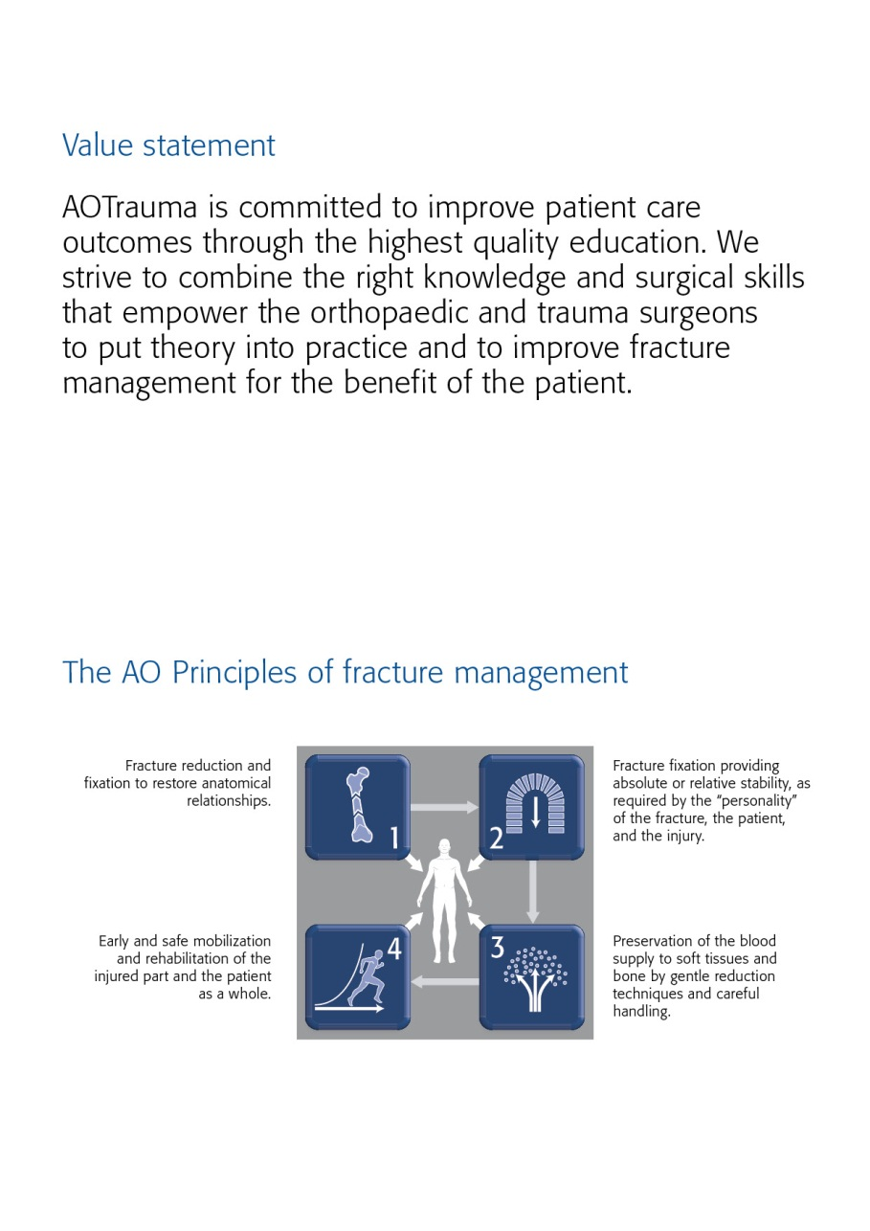

Dear AOTrauma course participant

We have the honour to welcome you to the AOTrauma Course—Principles in Operative Fracture Management run by the AOTrauma Specialty! We hope you will enjoy your course and the entire experience.

What is AOTrauma? We are the "clinical division"—a community for Trauma and Orthopaedics within the AO Foundation. As an AO Specialty we aim to integrate and align applied and clinical research, education, and community development functions into one direction—AOTrauma for the benefit of our members, stakeholders, and patients.

How AOTrauma benefits you? By working as a single team we will focus and better leverage our resources, expertise, and skills to create and deliver new and greater value to our members.

What does this mean in education? AOTrauma is committed to providing you the best possible educational experience by continuously embracing and introducing new educational techniques to help you learn and more effectively implement your knowledge for the benefit of your patients.

Why join AOTrauma? Joining AOTrauma means you are part of the “Trauma & Orthopaedic” community within the AO. AOTrauma will help you develop lifelong friendships and relationships; we will help you access our “knowledge network” and get involved in new opportunities that advance trauma care.

Yours sincerely,

*Photo Photo*

Kodi Kojima Nikolaus Renner

Chairperson AOTrauma Chairperson AOTrauma

Education Commission International Board

PS: Your experiences with us, over the next few days, will result in the realization of new and meaningful knowledge, skills, and understanding that we hope will translate into improved patient care.

The first AO Course was held in Davos in 1960—these early courses pioneered psychomotor techniques by teaching practical skills of AO Techniques. Since those early days over 250,000 surgeons and 135,000 ORP staff from over 110 countries have attended AO Courses—we now launch AOTrauma to move our education to the next level.

Content

Value statement

The AO principles

Dear AOTrauma course participant

Goal of the course

Target participants

Course objectives

Course description

Chairpersons

Faculty

Sunday, December 9, 2012

Monday, December 10, 2012

Tuesday, December 11, 2012

Wednesday, December 12, 2012

Thursday, December 13, 2012

Friday, December 14, 2012

Course organization

Course logistics

Course information

Course venue

Business center

Wireless network

Exhibitions

AO Research Institute Davos (ARI)

Transportation

Sponsors

Upcoming AO Courses–Davos 2013

AOTrauma Masters Course—Lower Extremity

Goal of the course

This year's AOTrauma Masters Courses address the latest concepts and best practices at the highest level. This course focuses on the latest techniques in operative fracture management dealing with the toughest lower extremity trauma problems, concentrating on the best available evidence and the latest techniques in operative fracture management. Our goal is to foster discussion, making use of real cases, and provoking open debate between participants and faculty members, complemented by lectures presenting the current

evidence. To round off the program, several joint sessions with your colleagues from the other two Masters Courses will offer a fresh perspective on some common themes, practical application of evidence, and insights into how the future of orthopaedic trauma can be applied in the clinic today.

Target participants

Participants must have already completed the AOTrauma Principles and Advances Courses. They should be actively involved in trauma management and preferably have more than 10 years of experience in orthopaedic trauma surgery. They should be willing to share their ideas and opinions and get involved. In order to optimize the educational experience for all, it is essential that participants have a very good knowledge of English.

Course objectives

Upon completion of this course participants should be able to:

* Assess and apply current evidence when managing complex fractures in the lower extremities:
  + Femoral head fractures
  + Complicated proximal femoral fractures
  + Hoffa fractures and complex distal femoral fractures
  + Complex tibial plateau fractures
  + Pilon fractures
* Outline and explain the latest concepts and techniques in the management of subtrochanteric femoral and complicated intertrochanteric fractures.
* Evaluate and apply new approaches in the lower extremities, such as:
  + Posterior approaches for tibial plateau fractures
  + Anterior and posterior approaches for femoral head fractures
  + Posteromedial and posterolateral approaches for pilon fractures

Course description

This course is targeted at surgeons with significant surgical expertise who are willing to share and explore their experiences with their peers and faculty. The AOTrauma Masters Course—Lower Extremity is built around open group discussions followed by interactive case-based presentations by experts in the field. They will introduce evidence and the latest concepts and techniques in the management of lower extremity fractures. They will also introduce the latest approaches and current opinions on implants for particular problems. Furthermore, participants will practice a variety of approaches on anatomical specimens. The course shares several joint sessions with the Masters Course—Upper Extremities and Masters Course—Complications and Complex Fractures, addressing common themes and making use of interactive learning approaches.

Chairpersons

**Cong Feng Luo Steven A Olson**

Shanghai, China Durham, USA

Faculty

|  |  |  |
| --- | --- | --- |
| Chong | Keen-Wai | Singapore |
| Dhillon | Mandeep | India |
| Fliri | Ladina | Switzerland |
| Forward | Daren | United Kingdom |
| Hanson | Beate | Switzerland |
| Kellam | James | USA |
| Larysz | Dariusz | Poland |
| Morrey | Chris | Australia |
| Oh | Chang-Wug | Korea South |
| Orthner | Ernst | Austria |
| Phiphobmongkol | Vajara | Thailand |
| Reid | J. | USA |
| Richards | R | Switzerland |
| Rüedi | Thomas | Switzerland |
| Stannard | James | USA |
| Stoddart | Martin | Switzerland |
| Stoffel | Karl | Australia |
| Van der Werken | Christiaan | Netherlands |
| Windolf | Markus | Switzerland |
| Zhou | Fang | China |
| Zura | Robert | USA |

Monday, December 10, 2012

|  |  |  |
| --- | --- | --- |
| Time | Agenda item | Who |
| 08:00–08:10 | Introduction | CF Luo, S Olson |
| 08:10–08:35 | Why am I here?  Why did I get up this morning? | S Olson |
| **Module 1** | **Distal tibia and pilon** | Moderator: S Reid |
|  | At the end of this module, participants will be able to:   * Describe the indications for open vs closed reduction * Discuss the choice of surgical approach |  |
| 08:35–10:10 | **Discussion group 1**  **Distal tibia and pilon**  Group 18  Group 19  Group 20  Group 21  Group 37  Group 42 | KW Chong, K Stoffel  D Forward, R Zura  S Reid, E Orthner  CW Oh, C Van der Werken  J Stannard, C Morrey |
| 10:10–10:40 | Coffee Break |  |
| 10:40–10:55 | Nailing techniques in the tibia | R Zura |
| 10:55–11:10 | MIPO in the tibia | V Phiphobmongkol |
| 11:10–11:40 | Management of pilon fractures | S Reid |
| 11:40–12:00 | Discussion |  |
| 12:00–13:00 | Lunch Break |  |
| 13:00–16:00 | Daily educational offering on modern and advanced technologies and surgical implants for individual choice of Continued Medical Education  - TIP Workshop: Multi LOC  - TIP Meet the Experts |  |
| **Module 2** | **Severe open fractures and soft-tissue coverage problems** | Moderator: R Zura |
|  | At the end of this module, participants will be able to:   * Identify priorities in acute open wound management * Identify techniques and indications for wound vac and bead pouch use * Discuss indications for managing bone loss after open fractures * Discuss key aspects of managing compartment syndromes |  |
| 16:00–17:40 | **Discussion group 2**  **Severe open fractures and soft-tissue coverage problems**  Group 18  Group 19  Group 20  Group 21  Group 37  Group 42 | R Zura, D Larysz  B Twaddle, V Phiphobmongkol  KW Chong, C Morrey  J Stannard, F Zhou  D Forward, S Reid |
| 17:40–18:10 | Coffee Break |  |
| 18:10–18:40 | Wound management in open fractures | J Stannard |
| 18:40–18:50 | Lower extremity compartment syndrome | B Twaddle |
| 18:50–19:00 | Management of bone loss following open fractures | R Zura |

Tuesday, December 11, 2012

|  |  |  |
| --- | --- | --- |
| Time | Agenda item | Who |
| **Module 3** | **Proximal femur injuries** | Moderator: S Olson |
|  | At the end of this module, participants will be able to:   * Discuss the risk factors for failure of DHS implant in intertrochanteric fractures * Discuss the indications for nail vs plate in subtrochanteric fractures * Discuss the indications for open reduction in femoral neck fractures |  |
| 08:00–09:40 | **Discussion group 3**  **Proximal femur injuries**  Group 18  Group 19  Group 20  Group 21  Group 37  Group 42 | R Zura, D Larysz  S Reid, V Phiphobmongkol  M Dhillon, E Orthner  CW Oh, C van der Werken  J Stannard, C Morrey |
| 09:40–10:10 | Coffee Break |  |
| 10:10–10:30 | Intertrochanteric hip fractures—pitfalls and new developments | C Van der Werken |
| 10:30–10:45 | Nailing techniques in subtrochanteric hip fractures | J Stannard |
| 10:45–11:00 | Subtrochanteric hip fractures – is there a place for plating | S Olson |
| 11:00–11:20 | Femoral neck fractures in young patients | D Forward |
| 11:20–11:30 | Femoral head fractures | S Olson |
| 11:30–12:00 | Discussion | S Olson |
| 12:00–13:00 | Lunch Break |  |
| 13:00–16:00 | Daily educational offering on modern and advanced technologies and surgical implants for individual choice of Continued Medical Education  - TIP Meet the Experts  - Siemens Workshop |  |
| **Module 4** | **Proximal tibia injuries** | Moderator:J Stannard |
|  | At the end of this module, participants will be able to:   * Discuss the indications for unicondylar vs bicondylar fixation * Discuss the role of locked plates on tibial plateau fractures * Discuss the acute management of knee instability after injury |  |
| 16:00–17:40 | **Discussion group 4**  **Proximal tibia fractures**  Group 18  Group 19  Group 20  Group 21  Group 37  Group 42 | KW Chong, K Stoffel  D Forward, F Zhou  V Phiphobmongkol, S Reid  M Dhillon, C Van der Werken  J Stannard, C Morrey |
| 17:40–18:10 | Coffee Break |  |
| 18:10–18:35 | Tibial plateau fractures | CF Luo |
| 18:35–18:45 | Knee instability | J Stannard |
| 18:45–19:00 | Discussion |  |

Wednesday, December 12, 2012

|  |  |  |
| --- | --- | --- |
| Time | Agenda item | Who |
| **Module 5** | **Distal femur injuries** | Moderator: C Morrey |
|  | At the end of this module, participants will be able to:   * Discuss indications for fixation of 33C fractures * Discuss indications for fixation of 33B fractures |  |
| 07:30–08:00 | TRANSFER TO HOSPITAL:  Meeting point 07:25 main entrance Congress Center  Preparation for the anatomical specimen lab |  |
|  | **GREEN TEAM** |  |
| 08:00–08:15 | Introduction to lab | Moderators: S Olson, CF Luo |
| 08:15–10:45 | **Anatomical specimen lab**  Surgical dislocation of the hip  Posterior approaches to the knee joint  Posterolateral, anterolateral, and posteromedial approaches to manage a pilon fracture | S Olson, CF Luo, S Reid, KW Chong, J Stannard |
|  | **RED TEAM** |  |
| 08:00–09:55 | **Discussion group 5**  **Distal femur fractures**  Group 18 red  Group 19 red  Group 20 red | B Twaddle, CW Oh  C Morrey, K Stoffel  F Zhou, E Orthner |
| 09:55–10:00 | LOCATION CHANGE TO LECTURE HALL |  |
| 10:00–10:20 | Complex distal femur fractures (33C) | C Morrey |
| 10:20–10:30 | Hoffa fractures (33B) | CW Oh |
| 10:30–10:45 | Discussion |  |
| 10:45–11:30 | SNACK Break |  |
|  | **RED TEAM** |  |
| 11:30–11:45 | Introduction to lab | Moderators: S Olson, CF Luo |
| 11:45–14:15 | **Anatomical specimen lab**  Surgical dislocation of the hip  Posterior approaches to the knee joint  Posterolateral ,anterolateral, and posteromedial approaches to manage a pilon fracture | S Olson, CF Luo, S Reid, KW Chong, J Stannard |
|  | **GREEN TEAM** |  |
| 11:30–13:25 | **Discussion group 5**  **Distal femur fractures**  Group 21 green  Group 37 green  Group 42 green | B Twaddle, CW Oh  C Morrey, K Stoffel  F Zhou, E Orthner |
| 13:25–13:30 | LOCATION CHANGE TO LECTURE HALL |  |
| 13:30–13:50 | Complex distal femur fractures (33C) | C Morrey |
| 13:50–14:00 | Hoffa fractures (33B) | CW Oh |
| 14:00–14:15 | Discussion |  |
| 14:15–15:15 | Lunch Break |  |
| 15:15–15:30 | TRANSFER TO THE CONGRESS CENTER |  |
| **Joint module** | **LOCATION Sanada**  All 3 Masters courses together  **AOTrauma Court** | Moderator: P Barbosa |
|  | At the end of this module, participants will be able to:  - Evaluate and apply evidence in everyday clinical life  - Distinguish between opinion and evidence |  |
| 16:00–16:20 | Evidence-based medicine | B Hanson |
| 16:20–17:20 | Presentation of court case  *(Proceedings ending in a jury)*  First vote | J Kellam |
| 17:20–17:30 | Evidence-based breakdown of the case | B Hanson |
| 17:30–17:50 | Open discussion | P Barbosa |
| 17:50–18:00 | Second vote |  |

Thursday, December 13, 2012

|  |  |  |
| --- | --- | --- |
| Time | Agenda item | Who |
| **Module 6** | **Hindfoot, midfoot, and forefoot fractures** | Moderator: KW Chong |
|  | At the end of this module, participants will be able to:   * Discuss the indications for fixation of calcaneus and talus fractures * Discuss the management of Lisfranc injuries * Discuss the management of ankle and hind foot nonunions |  |
| 08:00–09:40 | **Discussion group 6**  **Hindfoot, midfoot, and forefoot fractures**  Group 18  Group 19  Group 20  Group 21  Group 37  Group 42 | R Zura, D Larysk  B Twaddle, V Phiphobmongkol  M Dhillon, E Orthner  CW Oh, C Van der Werken  J Stannard, C Morrey |
| 09:40–10:10 | Coffee Break |  |
| 10:10–10:30 | Calcaneus fractures | KW Chong |
| 10:30–10:50 | Talus fractures | S Reid |
| 10:50–11:10 | Midfoot fractures | M Dhillon |
| 11:10–11:40 | Malunion in foot and ankle | E Orthner |
| 11:40–12:00 | Discussion |  |
| 12:00–13:00 | Lunch Break |  |
| 13:00–16:00 | Daily educational offering on modern and advanced technologies and surgical implants for individual choice of Continued Medical Education  - TIP Meet the Experts  - Siemens Workshop  - AO Center visit (bus leaves at 12:30) |  |
| 16:00–17:30 | My worst case and how I solved it (part 1) | D Larysz, S Olson, B Twaddle, S Reid, J Stannard, |
| 17:30–18:00 | Coffee Break |  |
| 18:00–19:00 | My worst case and how I solved it (part 2) | D Forward, V Phiphobmongkol, CW Oh, KW Chong |

Friday, December 14, 2012

|  |  |  |
| --- | --- | --- |
| Time | Agenda item | Who |
| **Module 7** | **Lower extremity fractures with difficult problems** | Moderator: K Stoffel |
|  | At the end of this module, participants will be able to:  - Discuss principles of periprosthetic fracture care  - Discuss principles of malunion treatment |  |
| 08:00–09:30 | **Discussion group 7**  **Lower extremity fractures with difficult problems**  Group 18  Group 19  Group 20  Group 21  Group 37  Group 42 | R Zura, D Larysk  B Twaddle, V Phiphobmongkol  C Morrey, KW Chong  K Stoffel, F Zhou  D Forward, S Reid |
| 09:30–09:35 | LOCATION CHANGE TO LECTURE HALL |  |
| 09:35–09:50 | Periprosthetic fractures in the lower extremity | K Stoffel |
| 09:50–10:10 | Malunion around the knee | CF Luo |
| 10:10–10:25 | Final discussion |  |
| 10:25–10:35 | Coffee Break |  |
| **Joint module** | **LOCATION Sanada**  All 3 Masters courses together  **The future is now**  **What’s new in orthopaedic trauma research** | Moderators: G Richards, S Olson |
| 10:35–10:50 | Navigation | M Windolf |
| 10:50–11:05 | What a surgeon needs to know about growth factors and stemcells | M Stoddart |
| 11:05–11:20 | Latest research in osteoporosis | L Fliri |
| 11:20-11:30 | Discussion | G Richards |
| 11:30–12:00 | Recent innovations from the TK systems | S Nork |
| 12:00–12:20 | Closing speech: reflection on AO and how it influenced my professional life | T Rüedi |
| 12:20–12:30 | Summary and closure of Masters Courses | P Brink |

Course organization

**AOTrauma**

Bettina Bolliger

Clavadelerstrasse 8

7270 Davos, Switzerland

Phone +41 81 414 27 22

Fax +41 81 414 22 84

Email bbolliger@aotrauma.org

Course logistics

**Industrial Partner**

DePuy Synthes

Luzernstrasse 21

4528 Zuchwil, Switzerland

Tel +41 32 720 40 60

Fax + 41 32 720 46 89

Website [www.depuysynthes.com](http://www.depuysynthes.com)

Course information

**Course fee**

AOTrauma Masters Course—Lower Extremity CHF 3’650.

Included in course fee are conference bag with documentation, coffee breaks, course certificate.

**Accreditation**

AOTrauma Courses are accredited for continuing medical education (CME) programs. The number of credit points or hours varies from country to country. The final information and number of credit points will be distributed with the course certificate.

**Evaluation guidelines**

All AOTrauma courses apply the same evaluation process, either audience response system (ARS) or paper and pencil questionnaires. This will help AOTrauma to ensure that we continue to meet your training needs. In some regions, CME accreditation is dependent on the participant’s evaluation results.

**Intellectual property**

Course materials, presentations, and case studies are the intellectual property of the course faculty. All rights are reserved. Check hazards and legal restrictions on www.aotrauma.org/legal.

🡪 **Recording, photographing, or copying of lectures, practical exercises, case discussions, or any course materials is strictly forbidden. Participants violating intellectual property will be dismissed.**

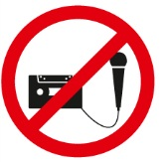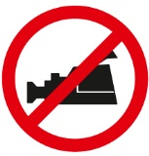

The AO Foundation reserves the right to film, photograph, and audio record during their events. Participants must understand that in this context they may appear in these recorded materials. The AO Foundation assumes participants agree that these recorded materials may be used for AO marketing and other purposes, and made available to the public.

**Security**

Security checks will be conducted at the entrance of the building. Wearing of a name tag is compulsory during lectures, workshops, and group discussions.

**No insurance**

The course organization does not take out insurance to cover any individual against accidents, thefts or other risks.

**Use of mobile phone**

Use of mobile phone is not allowed in the lecture halls and in other rooms during educational activities. Please be considerate of others by turning off your mobile phone.

**Dress code**

Course: casual or sportswear

Davos is a mountain resort. Warm clothes and suitable shoes are advisable.

**Hotels**

Participants who have not booked a package including hotel should settle their hotel bill directly when checking out.

**HRG travel office**

The HRG travel office will support you with flight confirmation or re-booking.

Course venue

**Congress Center Davos**

Talstrasse 49A

7270 Davos, Switzerland

Phone +41 81 414 62 00

Fax +41 81 414 62 29

**Welcome desk–opening hours**

General information/registration for special events

Sunday 15:00–17:00

Monday to Thursday 07:45–19:00

Friday 07:45–16:00

**Information/Faculty desk–opening hours**

Course information for faculty and participants

Sunday 15:00–17:00

Monday to Thursday 07:45–19:00

Friday 07:45–16:00

Business center

There are business center facilities in the Congress Center which are accessible to everybody.

**Services**

• Internet and e-mail access

• Printer access

• www.aotrauma.org

AO Course website offering course-related information.

**Location**

The business centers are available in different locations in the Congress Center.

**Opening hours**

30 minutes before the first course of the day starts until

30 minutes after the last course ends

**Disclaimer**

The use of your own computer in the business center network is inherently not secure. We strongly recommend that you take appropriate actions to protect your computer against unauthorized use or theft (eg, Firewall, VPN-Connection, VirusScanner, etc). AO cannot be held responsible for any data loss or theft.

For further information or support please contact:

AO Foundation

Phone +41 81 414 28 70

E-mail [it.support@aofoundation.org](mailto:it.support@aofoundation.org)

Wireless network

A special wireless network "AOBusiness" is accessible and free for everybody.

**Services**

• Internet and e-mail access

• www.aotrauma.org

AO Course website offering course-related information.

**Locations**

At public places in the Congress Center.

**How to connect**

• Open the wireless network connection window

• Choose the "AOBusiness" network as shown in the picture below and click on the connect button



• Open your internet browser

• Enter user name and password on the wireless connection site

Username: aowireless

Password: aowireless

• Press the OK button

Exhibitions

Visit the AO World in the main foyer, home of the new world of the AO Specialties: AOTrauma, AOSpine, AOCMF, and AOVET. At the specialty exhibits you can explore membership opportunities and the award winning Surgery Reference, examine our print and electronic publications, learn about the ground-breaking activities occurring within AO, and discover the research, development, fellowship, and other opportunities available to you. You can also visit with the Clinical Investigation and Documentation (CID), the AO Research Institute Davos, the TK Office and AO GCTM.

**Industry exhibitions**

Visit our industry partner DePuy Synthes

as well as a number of industry providers who will demonstrate the latest advances in their technologies:

BrainLab, Mathys Orthopädie, Siemens, Storz, Synbone.

AO Research Institute Davos (ARI)

**Mission**

Excellence in research and concept development within trauma and disorders of the musculoskeletal system and translation of this knowledge to achieve more effective patient care worldwide.

**Goals within the Mission**

* Contribute **high quality research and concept development**
* Investigate and **improve the performance** of surgical procedures, devices and substances
* Foster a **close relationship** with the AO medical community, academic societies, universities, and industry
* Provide research environment/support for AO clinicians

At the AO world booths, meet with our team including our ARI Medical Research Fellows, establish contacts, freely discuss your clinical problems, ideas, and learn about the latest results from the AO Research Institute Davos (ARI). On the tours of the AO Center, see our infrastructure under one roof and meet some of our research team.

Areas:

**Exploratory Collaborative Research Programs**

* Large Bone Defect Healing
* Annulus Fibrosus Rupture
* Acute Cartilage Injury

**CMF**

* Imaging and planning of surgery, computer aided preoperative planning
* Preclinical model development for Bisphosphonate-Related Osteonecrosis of the Jaw

**Spine**

* Degeneration and Regeneration of the Intervertebral Disc
* Fracture Fixation in Osteoporotic Bone

**Trauma**

* Bone Infection, including minimizing infection risk through implant design, diagnostics of infection through novel imaging techniques
* Fracture Fixation in Osteoporotic Bone including Intra-operative assessment of bone quality, augmentation techniques and prophylaxis
* Evaluation of the cortical and trabecular bone remodeling (with special regards to the porosity) in the proximal humerus and its impact on the fracture zones

**Veterinary**

* External fixation implant for large animals
* Development of new implants for small animals

**Multidisciplinary**

* Analysis of implant-specific functional anchorage with CT-technology
* Ex-vivo testing using advanced biomechanical models
* In-vivo studies using established or newly developed preclinical models
* Gene Transfer- non viral and viral
* Implant design using the Finite Element Methods
* Implant positioning assistance, C Arm guided implant placement
* Telemetric monitoring of bone healing
* In vivo and in vitro quantification of bone turnover and scaffold degradation
* Longitudinal analysis within in-vivo studies using CT technology
* Medical image processing and analysis
* Polymers to deliver cells and biological factors, create potential space for tissue development, and guide the process of tissue regeneration
* Prototype development and production
* Stem cell therapies for the treatment of bone, intervertebral disc and cartilage defects
* Bioreactor Culture systems and mechanobiology
* Surface modification of PEEK to improve tissue integration
* Thermosresponsive Gel for delivery of antibiotics, stem cells, growth factors, transfected cells etc.

For the 2012 AO Research Institute Davos, activity report and recent publications go to http://www.aofoundation.org/ari/publications

Transportation

**Special bus for course participants**

Wednesday and Thursday

**12:15** Congress Center–AO Center

**13:30** AO Center–Congress Center

Local buses run every 10 minutes during the day.

Sponsors

We would like to thank our partner **DePuy Synthes** for their support without which this event would not be possible.

A special thanks to our main sponsors:

**Audi**

**Siemens**

We also extend our thanks to the following co-sponsors:

**BrainLab**

**Credit Suisse**

**Synbone**

**Storz**

Upcoming AO Courses—Davos 2013

**AO Course–November 30–December 5, 2013**

* AOTrauma Swiss Residents Course—Principles in Operative Fracture Management
* AOTrauma Fortgeschrittenen-Kurs für operative Frakturbehandlung
* AOTrauma Masters Course—Current Concepts
* AOTrauma Course—Hand and Wrist
* AOCMF Course—Principles in Craniomaxillofacial Fracture Management
* AOVET Courses

**AO Course–December 8–13, 2013**

* AOTrauma Course—Principles in Operative Fracture Management
* AOTrauma Course—Advances in Operative Fracture Management
* AOTrauma Masters Course—Lower Extremity
* AOTrauma Masters Course—Upper Extremity
* AOTrauma Masters Course—Complications and Complex fractures
* AOSpine Courses

List subject to changes. The final Davos courses list as well as worldwide courses lists will be available on [www.aotrauma.org](http://www.aotrauma.org) in January 2013.

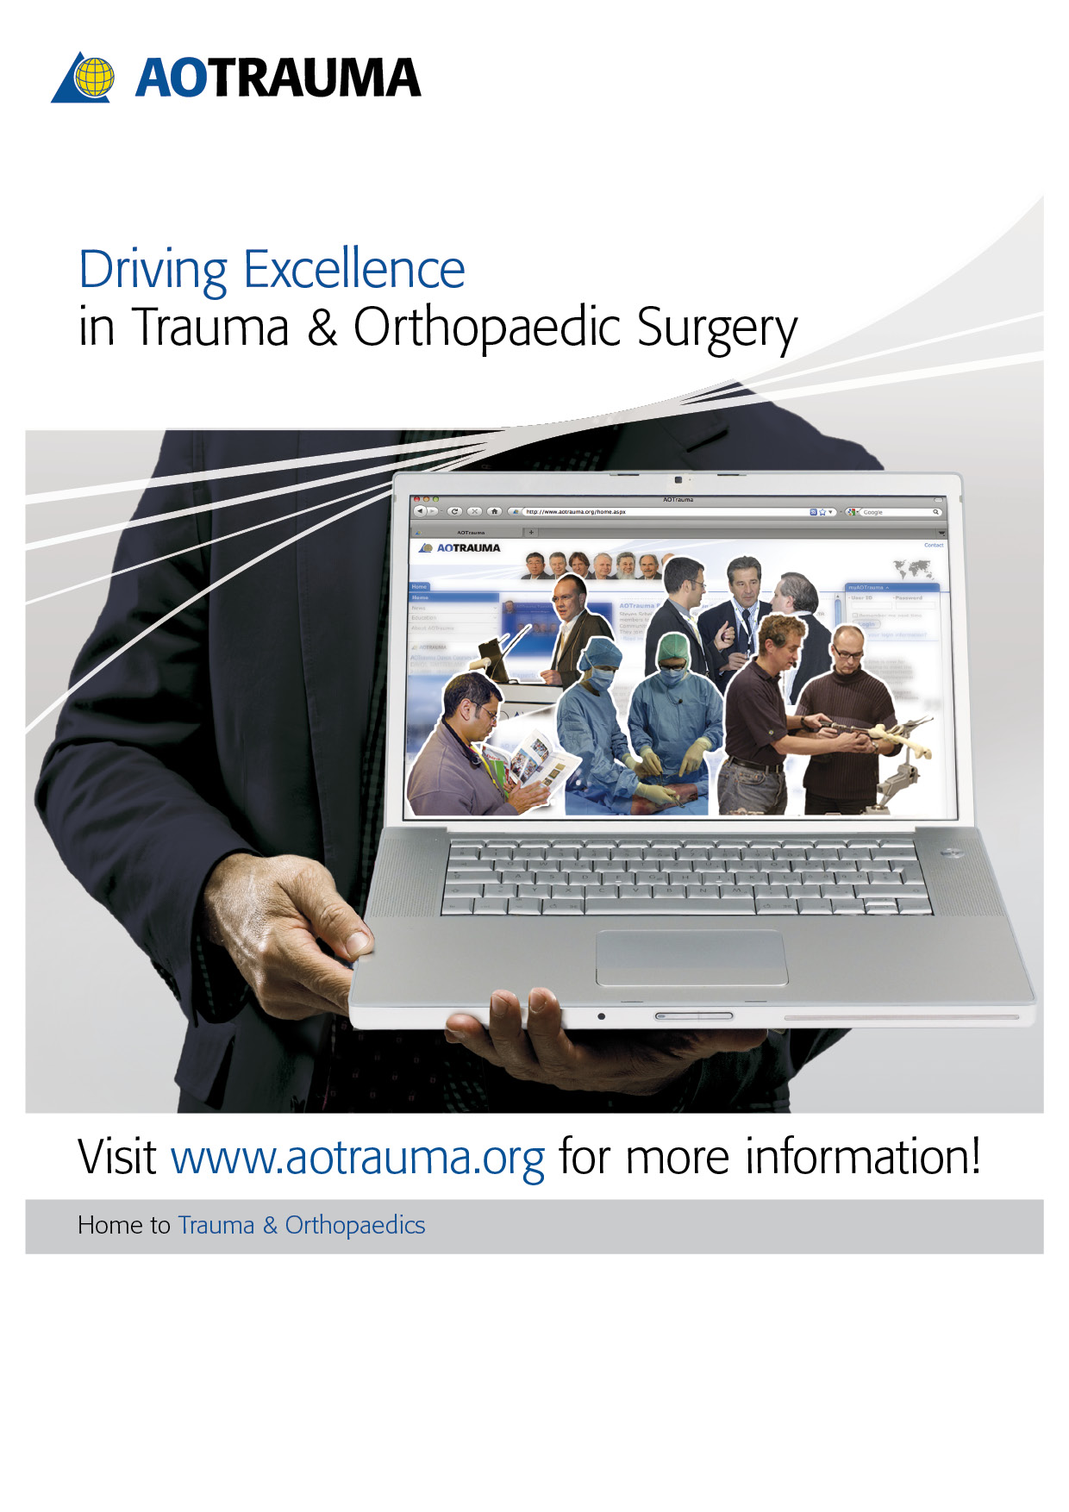

AOTrauma Clavadelerstrasse 8, 7270 Davos Platz, Switzerland

Phone +41 81 414 27 20, F +41 81 414 22 84, courses@aotrauma.org

Logistics and support provided by an educational grant from Synthes.